TS 200 BS/EL TS 200 BS/EL P
0 7 0 7
232039003 - GB

USE AND MAINTENANCE MANUAL SPARE PARTS CATALOG

11/01/01 23203M00
preparato da UPT approvato da DITE

© MOSA | 1.0-11/99 | SYMBOLS AND SAFETY PRECAUTIONS | GE_, MS_, TS_ | M 2

SYMBOLS IN THIS MANUAL

- The symbols used in this manual are designed to call your attention to important aspects of the operation of the machine as well as potential hazards and dangers for persons and things.

IMPORTANT ADVICE

- Advice to the User about the safety:

☞ N.B.: The information contained in the manual can be changed without notice.
Potential damages caused in relation to the use of these instructions will not be considered because these are only indicative.
Remember that the non observance of the indications reported by us might cause damage to persons or things.
It is understood, that local dispositions and/or laws must be respected.

WARNING

Situations of danger - no harm to persons or things

Do not use without protective devices provided Removing or disabling protective devices on the machine is prohibited.

Do not use the machine if it is not in good technical condition
The machine must be in good working order before being used. Defects, especially those which regard the safety of the machine, must be repaired before using the machine.

SAFETY PRECAUTIONS
DANGEROUS
This heading warns of an immediate danger for persons as well for things. Not following the advice can result in serious injury or death.
WARNING
This heading warns of situations which could result in injury for persons or damage to things.

CAUTION
To this advice can appear a danger for persons as well as for things, for which can appear situations bringing mate- rial damage to things.

IMPORTANT

NOTE

ATTENTION
These headings refer to information which will assis you in the correct use of the machine and/or accessories.

26/11/99 M2GB

© MOSA | 1.1-04/03 | SYMBOLS AND SAFETY PRECAUTIONS | GE_, MS_, TS_ | M 2-1

SYMBOLS (for all MOSA models)

STOP - Read absolutely and be duly attentive

Read and pay due attention

GENERAL ADVICE - If the advice is not respected damage can happen to persons or things.

HIGH VOLTAGE - Attention High Voltage.There can be parts in voltage, dangerous to touch. The non observance of the advice implies life danger.

FIRE - Danger of flame or fire. If the advice is not respected fires can happen.

HEAT - Hot surfaces. If the advice is not respected burns or damage to things can be caused.

EXPLOSION - Explosive material or danger of explosion. in general. If the advice is not respected there can be explosions.

WATER - Danger of shortcircuit. If the advice is not respected fires or damage to persons can be caused.

SMOKING - The cigarette can cause fire or explosion. If the advice is not respected fires or explosions can be caused.

ACIDS - Danger of corrosion. If the advice is not respected the acids can cause corrosions with damage to persons or things.

WRENCH - Use of the tools. If the advice is not respected damage can be caused to things and even to persons.

PRESSION - Danger of burns caused by the expulsion of hot liquids under pressure.
PROHIBITIONS No harm for persons
Use only with safety clothing -
It is compulsory to use the personal protection means given in equipment.

Use only with safety clothing -
It is compulsory to use the personal protection means given in equipment.

Use only with safety protections -
It is a must to use protection means suitable for the different welding works.

Use with only safety material -
It is prohibited to use water to quench fires on the electric machines.

Use only with non inserted voltage -
It is prohibited to make interventions before having disinserted the voltage.

No smoking -
It is prohibited to smoke while filling the tank with fuel.

No welding -
It is forbidden to weld in rooms containing explosive gases.

ADVICE No harm for persons and things

Use only with safety tools, adapted to the specific use -
It is advisable to use tools adapted to the various maintenance works.

Use only with safety protections, specifically suitable It is advisable to use protections suitable for the different welding works.

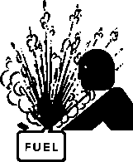
Use only with safety protections -
It is advisable to use protections suitable for the different daily checking works.
Use only with safety protections -
It is advisable to use all protections while shifting the machine.

Use only with safety protections -
It is advisable to use protections suitable for the different daily checking works.and/or of maintenance.

ACCES FORBIDDEN to non authorizad peaple.
26/11/99 M2-1GB

© MOSA | 1.0-06/00 | INSTALLATION AND ADVICE BEFORE USE | GE_, MS_, TS_ | M 2-5
DANGEROUS
10/06/00 M2-5I
The installation and the general advice concerning the operations, are finalized to the correct use of the machine, in the place where it is used as generator group and/or welder.

ENGINE | Stop engine when fueling | CHECKING BOARD | Do not touch electric devices if you are barefoot or with wet clothes.
 | Do not smoke, avoid flames, sparks or electric tools when fueling.
 | Unscrew the cap slowly to let out the fuel vapours. |  | Always keep off leaning surfaces during work operations
 | Slowly unscrew the cooling liquid tap if the liquid must be topped up.
 | The vapor and the heated cooling liquid under pressure can burn face, eyes, skin. |  | Static electricity can demage the parts on the circuit.
 | Do not fill tank completely.
 | Wipe up spilled fuel before starting engine. |  | An electric shock can kill
 | Shut off fuel of tank when moving machine (where it is assembled).
 | Avoid spilling fuel on hot engine.
 | Sparks may cause the explosion of battery vapours

☞ FIRST AID. In case the operator shold be sprayed by accident, from corrosive liquids a/o hot toxic gas or whatever event which may cause serious injuries or death, predispose the first aid in accordance with
the ruling labour accident standards or of local instructions.

Skin contact | Wash with water and soap
Eyes contact | Irrigate with plenty of water, if the irritation persists contact a specialist
Ingestion | Do not induce vomit as to avoid the intake of vomit into the lungs, send for a doctor
Suction of liquids from  lungs | If you suppose that vomit has entered the lungs (as in case of spontaneous vomit) take the  subject to the hospital with the utmost urgency
Inhalation | In case of exposure to high concentration of vapours take immediately to a non polluted zone  the person involved
☞ FIRE PREVENTION. In case the working zone,for whatsoever cause goes on fire with flames liable to cause severe wounds or death, follow the first aid as described by the ruling norms or local ones.

EXTINCTION MEANS
Appropriated | Carbonate anhydride (or carbon dioxyde) powder, foam, nebulized water
Not to be used | Avoid the use of water jets
Other indications | Cover eventual shedding not on fire with foam or sand, use water jets to cool off the  surfaces close to the fire
Particular protection | Wear an autorespiratory mask when heavy smoke is present
Useful warnings | Avoid, by appropriate means to have oil sprays over metallic hot surfaces or over electric contacts (switches,plugs,etc.). In case of oil sprinkling from pressure circuits, keep in mind that the inflamability point is very low.
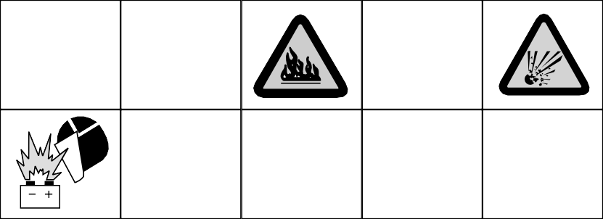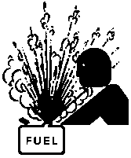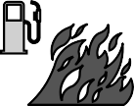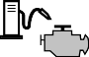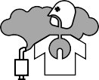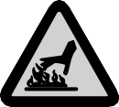
WARNING
CAUTION

WARNING
THE MACHINE MUST NOT BE USED IN AREAS WITH EXPLOSIVE ATMOSPHERE

© MOSA | 1.0-03/00 | PRECAUTION (ENGINE DRIVEN WELDER) | GE_, MS_, TS_ | M 2-5-₁

INSTALLATION AND ADVICE BEFORE USE

The operator of the welder is responsible for the security of the people who work with the welder and for those in the vicinity.
The security measures must satisfy the rules and regulations for engine driven welders. The information given below is in addition to the local security norms.

Estimate possible electromagnetic problems in the work area taking into account the following indications.
  - Telephonic wirings and/or of communication, check wirings and so on, in the immediate vicinity.
  - Radio and television receptors and transmettors.
  - Computer and other checking devices.
  - Critical devices for safety and/or for industrial checks.
  - Peapol who, for instance, use pace-maker, hearing-aid for deaf or something and else.
  - Devices used for rating and measuring.
  - The immunity of other devices in the operation area of the welder. Make sure that other used devices are compatible. If it is the case, provide other additional measures of protection.
  - The daily duration of the welding time.
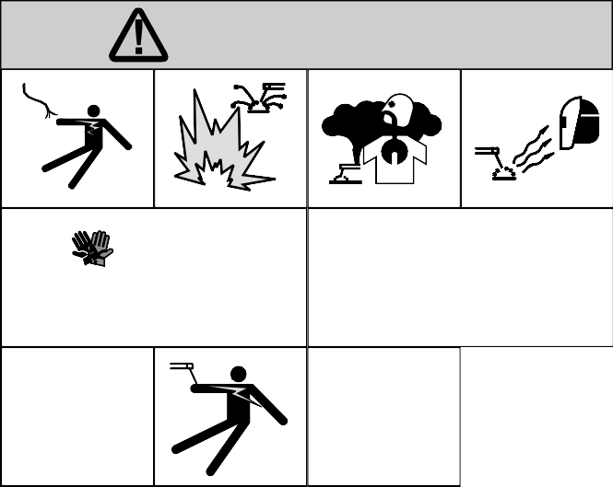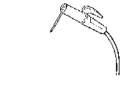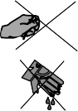
ATTENTION

Make sure that the area is safe before starting any welding operation.

➠Do not touch any bare wires, leads or contacts as they may be live and there is danger of electric shock which can cause death or serious burns. The electrode and welding cables, etc. are live when the unit is
operating.
➠Do not touch any electrical parts or the electrode while standing in water or with wet hands, feet or clothes.
➠Insulate yourself from the work surface while welding. Use carpets or other insulating materials to avoid
physical contact with the work surface and the floor.
➠Always wear dry, insulating glovers, without holes, and body protection.
➠Do not wind cables around the body.
➠Use ear protections if the noise level is high.
➠Keep flamable material away from the welding area.
➠Do not weld on containers which contain flamable material.
➠Do not weld near refuelling areas.
➠Do not weld on easily flamable surfaces.
➠Do not use the welder to defrost (thaw) pipes.
➠Remove the electrode from the electrode holder, when not welding.
➠Avoid inhaling fumes by providing a ventilation system or, if not possible, use an approved air breather.
➠Do not work in closed areas where there is no fresh air flow.
30/03/00 M2-5GB
➠Protect face and eyes (protective mask with suitable dark lens and side screens), ears and body (non-
flamable protective clothers).

INSTALLATION AND ADVICE

INSTALLATION AND ADVICE BEFORE USE
M 2.6
© MOSA REV.1-06/07

GASOLINE ENGINES
    - Use in open space, air swept or vent exhaust gases, which contain the deathly carbone oxyde, far from the work area.

DIESEL ENGINES
    - Use in open space, air swept or vent exhaust gases far from the work area.
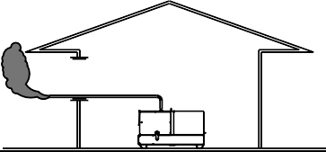
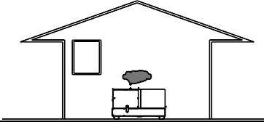

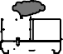

POSITION
Place the machine on a level surface at a distance of at least 1,5 m from buildings or other plants.
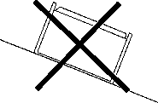

Maximum leaning of the machine (in case of dislevel)
26/11/99 M2-6GB
Check that the air gets changed completely and the hot air sent out does not come back inside the set so as to cause a dangerous increase of the temperature.

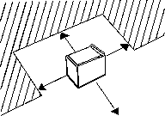☞ Make sure that the machine does not move during the work: block it possibly with tools and/or devices
made to this purpose.

MOVES OF THE MACHINE
☞ At any move check that the engine is off, that there are no connections with cables which impede the
moves.

PLACE OF THE MACHINE
For a safer use from the operator DO NOT fit the machine in locations with high risk of flood.
Please do not use the machine in weather conditions which are beyond IP protection shown both in the data plate and on page named "technical data" in this same manual.
ATTENTION

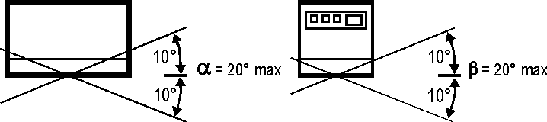

© MOSA | 1.0-01/01 | TRANSPORT AND DISPLACEMENTS COVERED UNITS | GE_, MS_, TS_ | M 4-1
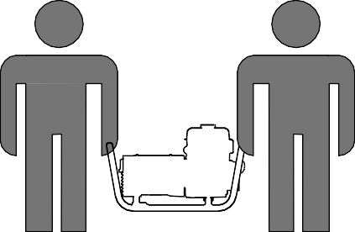
NOTE
15/01/01 M4GB
In case you should transport or move the machine, keep to the instructions as per the figures.
Make the transportation when the machine has no petrol in its tank, no oil in the engine and and electrolyte in the battery.
Be sure that the lifting devices are: correctly mounted, adequate for the weight of the machine with it’s packaging, and conform to local rules and regulations.
Only authorized persons involved in the transport of the machine should be in the area of movement.

DO NOT LOAD OTHER PARTS WHICH CAN MODIFY WEIGHT AND BARICENTER POSITION.
IT IS STRICTLY FORBIDDEN TO DRAG THE MACHINE MANUALLY OR TOW IT BY ANY VEHICLE (model with no
CTM accessory).
If you did not keep to the instructions, you could damage the structure of the machine.

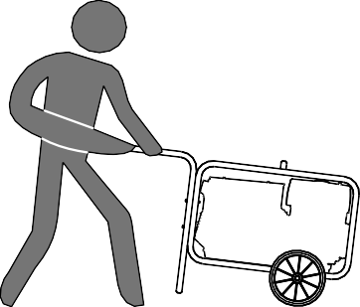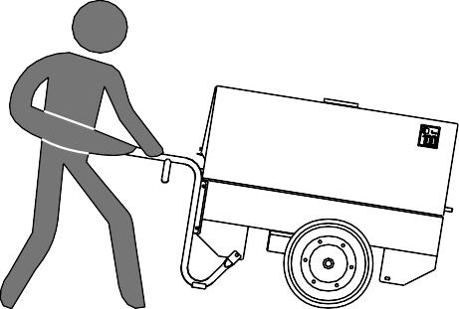
Weight max. per person: 35 kg Total max. weight; 140 kg
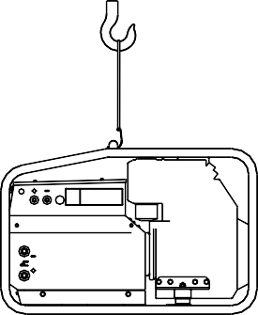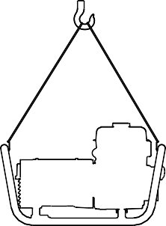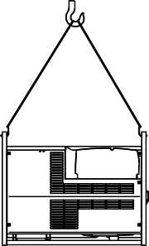

© MOSA | 1.1-01/04 | ASSEMBLY | CTM 6/6UK CTM 6/2 CTM 200 | PB1 PB2 PB3 | M 6
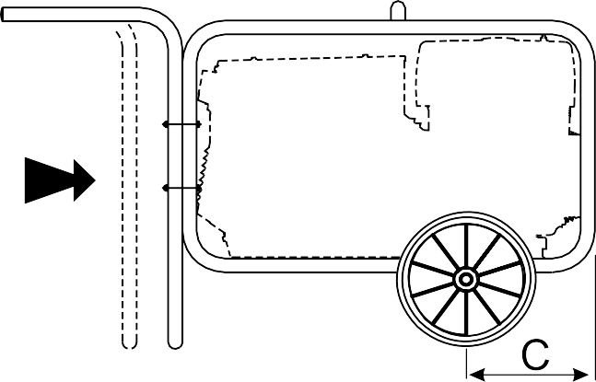
ATTENTION
21/05/03 M6GB
The CTM accessory cannot be removed from the machine and used separately (actioned manually or following vehicles) for the transport of loads or anyway for used different from the machine movements.
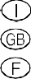
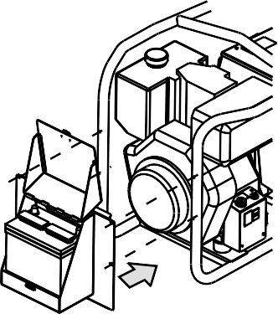Note: Lift the machine and assemble the parts as shown in the drawing

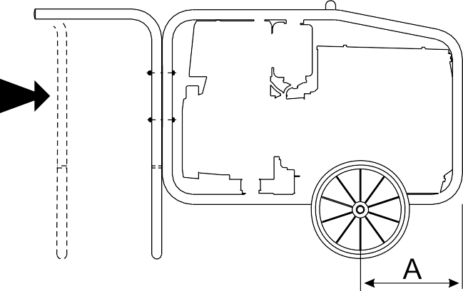
CTM 6/2

PB1 PB2 PB3

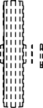
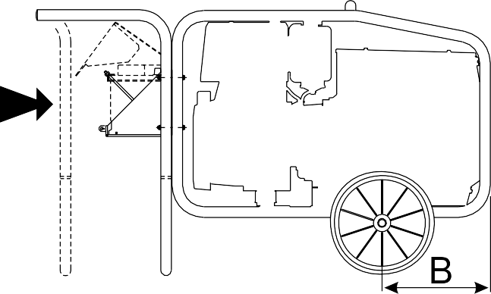
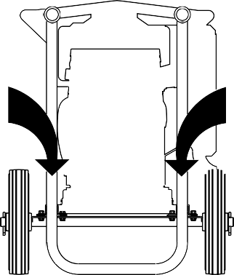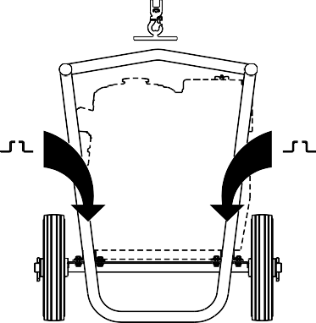CTM 6/6UK

CTM 200

GE 7000 BS/GS  GE 6000 DS/GS  GE 6000 DES/GS  GE 7500 BS/GS  GE 6500 DS/GS  GE 6500 DES/GS | CTM 200 CTM 6/2 CTM 6/6UK  CTM 200 CTM 6/2 CTM 6/6UK | C A B  C A B | 145 mm  310 mm  400 mm  205 mm  400 mm  400 mm

© MOSA | REV.1-09/06 | SETTING-UP THE UNIT (GASOLINE ENGINES) | GE_, MS_, TS_ | M 25

BATTERY WITHOUT MAINTENANCE
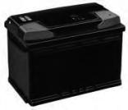
Connect the cable + (positive) to the pole + (positive) of the battery (after having taken away the protection), by properly tightening the clamp.
Check the state of the battery from the colour of the warning light which is in the upper part.

- Green colour: battery OK
- Black colour: battery to be recharged
- White colour: battery to be replaced

DO NOT OPEN THE BATTERY.

LUBRICANT

Check the level of the engine oil using the (appropriate oil dipstick: the level should be between the minimum and maximum marks.
ASTINA LIVELLO OLIO
MAX
LIVELLO OPERATIVO

MIN

lf necessary, add more oil through the appropriate inlet

Fill the air filter using the same oil up to the level indicated on the filter (machine with oil bath air filter).

OIL RECOMMENDED
MOSA advises to choose AGIP for the type of oil.

Please keep to the label put on the engine for the recommended products.

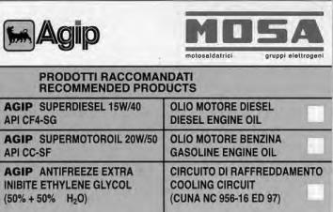

☞ NOTE: before starting and switching off, see instructions in the engine owner’s manual herewith attached.

FUEL

Check the level of fuel in the tank and, if necessary, add more standard gasoline of any type you can buy (e.g. 84-96 ON).

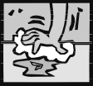
If during the filling of the tank some gasoline is accidentally spilled around the engine chassis, clean it immediately before starting up the engine.

ENGINE WITH OIL ALERT DEVICE

The OIL ALERT device will stop the engine in case of no oil or insufficient amount of oil in the engine.

In case one tries to start the engine with oil below the minimum level, the warning light (when assembled) will light and the device will not allow starting.

CLEANING OF DRY AIR FILTER
See page M43.

GROUND CONNECTION

☞ lt is obligatory to connect the ground connection point (12) by means of a sure
efficient cable (please follow the installation local rules and/or regulations in force) in order to integrate or ensure the working of various electric protection devices referring to the several distribution systems TN.

The unit can be started only when the above operations have been correctly performed.

17/05/01 M25-GB

© MOSA | REV.0-06/99 | STARTING THE ENGINE (GASOLINE ENGINES) | GE_, MS_, TS_ | M 26

Check daily
Do not alter the primary conditions of regulation and do not touch the sealed parts.
NOTE

ENGINES WITH ELECTRIC START

Ilnsert the electric protection device (D-Z2-N2) lever towards above and, where mounted, check the isolation monitor (A3) see page M37 -

Check the battery connection with the respective terminals (+) (-).

Open the gosoline cock; use the starter if the engíne is cold and the temperature is low.

Pull the rope hard and fast. Pull it all the way out. Use two hands if necessary.

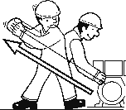
Then returning it slowly.
Once the engine is started, with the starter off, let it turn for a few minutes before drawing the load.

Accelerate the machine by means of the right lever (16), when it is assembled.

EMERGENCY START
(wlth rope)

In the versions with electric start, in case of need, it is possible to start the engine with the rope.

START
OFF
ON
Introduce the key (Q1), turn it clockwise completely, leaving it as soon as the engine starts and/or the push button (32) (models without key) leaving it as soon as the engine starts.

☞ NB.: for safety reason the key must be kept by qualified personel.

Once the engine is started, with the starter off, let it turn for a few minutes before drawing the load.

Accelerate the machine by means of the right lever (16), when it is assembled.
If the engine fails to start, do not insist for at least 15 seconds.

Space the further operations waiting for at least 4 minutes.
CAUTION

ENGINE WITH NO ELECTRIC START

lnsert the electric protection device (D-Z2-N2) lever towards above and, where mounted, check the isolation monitor (A3) see page M37-

Open the gasoline cock; use the starter if the engine is cold and the temperature is low.
RUNNING-IN
During the first 50 hours of operation, do not use more than 60% of the maximum output power of the unit and check the oil level frequently., in any case please stick to the rules given in the engine use manual.
CAUTION

Hold the starting handle firmly.
14/06/99 M25-GB

© MOSA | REV.0-06/99 | STOPPING THE ENGINE (GASOLINE ENGINE) | GE_, MS_, TS_ | M 27

☞ Before stopping the engine it is compulsory to effect the following operations:
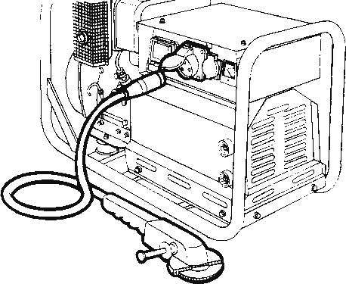
- stop to draw three/single-phase current from the auxiliary sockets.
- stop to draw power from the welding sockets (only for TS models).
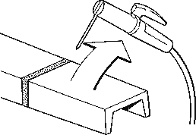

ENGINES WITH ELECTRIC START

☞ Make sure that the machine is not under load.
Wait for a few minutes to allow the engine to cool down, anyway follow the instructions contained in the engine manual.

Shut the gasoline cock.

OFF ON

START
Take out the key (Q1), turning it counter clockwise (when assembled) or pressing the stop button (32) until the engine stops.

☞ NB.: for safety reason the key must be kept by qualified personel.

ENGINES WITHOUT ELECTRIC START
☞ Make sure that the machine is not under load.
Wait for a few mìnutes to allow the engine to cool down, take however into consideration the prescriptions given in the engine use manual.

Shut the gasoline cock.

Set the engine switch (32) to the OFF position.
14/06/99 M25-GB

© MOSA | 1.0-05/01 | CONTROLS | LEGENDE | GE_, | MS_, | TS_ | M 30
10/05/01 M30-GB
4A  9 | Hydraulic oil level light Welding socket ( + ) | B4 B5 | Exclusion indicating light PTO HI Auxiliary current push button
10 | Welding socket ( - ) | C2 | Fuel level light
12 | Earth terminal | C3 | E.A.S. PCB
15 | A.C. socket | C6 | Control unit for generating sets QEA
16 | Accelerator lever | D | Ground fault interrupter ( 30 mA )
17 | Feed pump | D1 | Engine control unit and economiser EP1
19 | 48V D.C. socket | D2 | Ammeter
22 | Engine air filter | E2 | Frequency meter
23 | Oil level dipstick | F | Fuse
24 | Engine oil reservoir cap | F3 | Stop switch
24A | Hydraulic oil reservoir cap | F5 | Warning light, high temperature
24B | Water filling cap | F6 | Arc-Force selector
25 | Fuel prefilter | G1 | Fuel level transmitter
26 | Fuel tank cap | H2 | Voltage commutator
27 | Muffler | H6 | Fuel electro pump
28 | Stop control | I2 | 48V A.C. socket
29 | Engine protection cover | I3 | Welding scale switch
30 | Engine cooling/alternator fan belt | I4 | Preheating indicator
31 | Oil drain tap | I5 | Y/▲ switch
31A | Hydraulic oil drain tap | I6 | Start Local/Remote selector
31B | Water drain tap | L | A.C. output indicator
31C | Exhaust tap for tank fuel | L5 | Emergency button
32 | Button | L6 | Choke button
33 | Start button | M | Hour counter
34 | Booster socket 12V | M1 | Warning level light
34A | Booster socket 24V | M2 | Contactor
35 | Battery charge fuse | M5 | Engine control unit EP5
36 | Space for remote control | M6 | CC/CV switch
37 | Remote control | N | Voltmeter
42 | Space for E.A.S. | N1 | Battery charge warning light
42A | Space for PAC | N2 | Thermal-magnetic circuit breaker/Ground fault interrupter
47 | Fuel pump | N5 | Pre-heat push-button
49 | Electric start socket | N6 | Connector - wire feader
54 | Reset button PTO HI | O1 | Oil pressure warning light/Oil alert
55 | Quick coupling m. PTO HI | P | Welding arc regulator
55A | Quick coupling f. PTO HI | Q1 | Starter key
56 | Hydraulic oil filter | Q3 | Derivation box
59 | Battery charger thermal switch | Q4 | Battery charge sockets
59A | Engine thermal switch | Q7 | Welding selector mode
59B | Aux current thermal switch | R3 | Siren
59C | Supply thermal switch wire feeder-42V | S | Welding ammeter
59D | Pre-heater (spark plug) thermal switch | S1 | Battery
59E | Supply thermal switch oil/water heather | S3 | Engine control unit EP4
59F | Electropump thermal switch | S6 | Wire feeder supply switch
63 | No load voltage control | S7 | Plug 230V singlephase
66 | Choke control | T | Welding current regulator
67A | Auxiliary / welding current control | T4 | Dirty air filter warning light/indicator
68 | Cellulosic electrodes control | T5 | Earth leakage relay
69A | Voltmeter relay | T7 | Analogic instrument V/Hz
70 | Warning lights | U | Current trasformer
71 | Selecting knob | U3 | R.P.M. adjuster
72 | Load commut. push button | U4 | Polarity inverter remote control
73 | Starting push button | U5 | Relase coil
74 | Operating mode selector | U7 | Engine control unit EP6
75 | Power on warning light | V | Welding voltage voltmeter
76 | Display | V4 | Polarity inverter control
79 | Wire connection unit | V5 | Oil pressure indicator
86 | Selector | W1 | Remote control switch
86A | Setting confirmation | W3 | Selection push button 30 l/1' PTO HI
87 | Fuel valve | W5 | Battery voltmeter
88 | Oil syringe | X1 | Remote control socket
A3 | Insulation monitoring | Y3 | Button indicating light 20 l/1' PTO HI
A4 | Button indicating light 30 l/1' PTO HI | Y5 | Commutator/switch, serial/parallel
B2 | Engine control unit EP2 | Z2 | Thermal-magnetic circuit breaker
B3 | E.A.S. connector | Z3 | Selection push button 20 l/1' PTO HI
 |  | Z5 | Water temperature indicator

© MOSA | 1.0-12/00 | Comandi Controls  Commandes | D  E NL | Bedienelemente | TS 200 BS/EL P - GE 6000 BS | M 31
06/12/00 23312-I
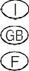
TS 200 BS GE 6000 BS
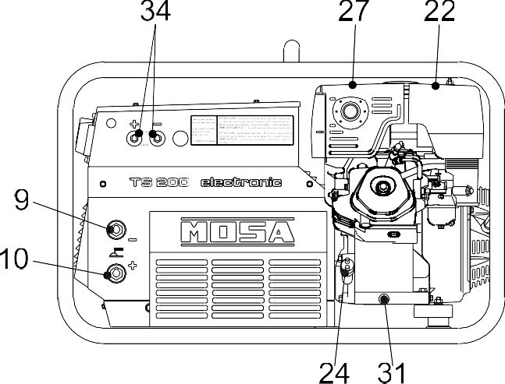
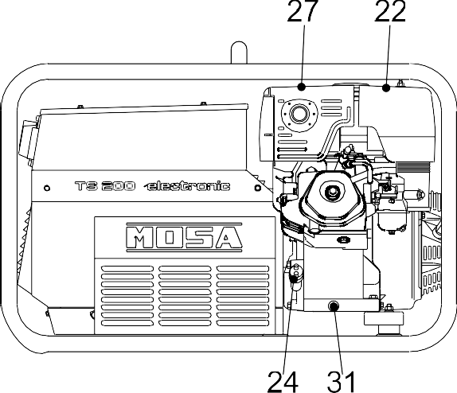

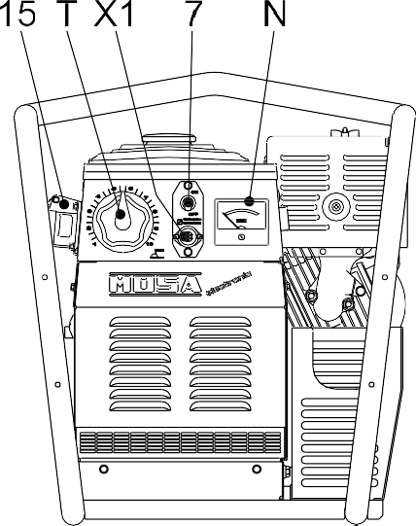
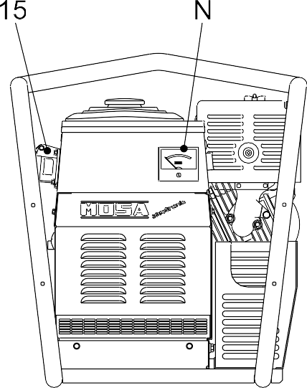
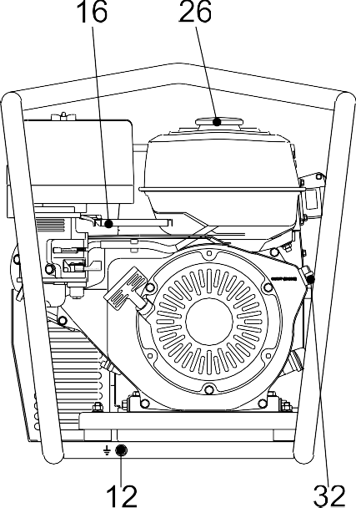

© MOSA | 1.0-04/04 | USE AS WELDER | TS | M 34

This symbol (Norm EN 60974-1 security standards for arc welders ) signifies that the welder can be used in areas with increased risk of electrical shock.

The sockets, after the machine is started (see pages M21-26), also with no cables, are anyway under voltage.
ATTENTION

The areas, access of which is forbiden to unqualified personel, are:
- the control switchboard (front) - the exhaust of the endothermic engine - the welding process.
ATTENTION
Check at the beginning of any work the electric parameters and/or the control placed on the front.

Make sure that the ground connection (12) is efficent (keep to installation local rules and/or to national laws), in order to integrate or ensure the working of varius electric protection devices referring to the several distribution system TT/TN/IT, operation unnecessary for machine with isometer.

Fully insert the welding cable plugs into the corresponding sockets (“only gauging”, 9+/10-) turnning them clockwise to lock them in position.

MACHINES WITH E.V. PROTECTION
Accelerate the engine at max. with the accelerator lever (16).See page M 39.

MACHINE WITH E.P.2 PROTECTION (B2)
Accelerate the engine at max. with the accelerator lever (16) (when assebled).
See page M 39

MACHINE WITH E.P.1 PROTECTION (D1)
See page M 39.1

REMOTE CONTROL TC…
See page M 38

WELDING CURRENT REGULATOR
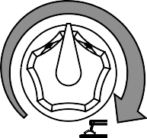
Position welding current adjusting knob (T) in correspondance of the chasen current value, so as to obtain the necessary amperage, taking into acount the diameter and the type of the electrode.
For technical data see page M52

ONLY GOUGING
To reduce the risk of electromagnetic interferences, use the minimum lenght of welding cables and keep them near and down (ex. on the floor).
The welding operations must take place far from any sensitive electronic device.Make sure that the unit is earthed. (see M20 and/or M25). In case the interference should last, adapt further disposition,such as: move the unit, use screened cables, line filters, screen the entire work area. In case the above mentioned operations are non sufficient, please contact our Thechnical Assistance Service.
ATTENTION

PUSH AND TWIST

☞ Make sure that the ground clamp ,whose cable must be connected to the + or - terminal,
depending on the type of electrode, makes a good connection and is near to the welding position.
With a welding cable length up to 20 m is suggested a section of 35 mm²; wìth longer cables a bigger section is required.
CAUTION
Pay attention to the two polarities of the welding circuit, which must not come in electric contact between themselves.
When using the welder for air arc gouging connect the ground lead to the - socket and the gouging lead to the socket marked "only gouging" (if present).
06/04/04 M34-GB

© MOSA | 1.0-04/04 | USE AS WELDER | TS | M 34.1

MACHINE WITH REDUCTION SCALE SWITCH
"CC/CV" MODELS

100%
XXX A
max
For small electrodes (up to Ø 3.25-130A and 4-200A) it is recommended to use the reduction scale switch (I3) allowing a more accurate regulation of the welding current (lever position at 130 A and/or 200A).
These models can be used with
CC electrodes or for TIG welding by selecting the CC (constant current) mode, and with solid wire (MIG, MAG)
CV or flux cored wire selecting the CV (constant voltage) mode. The mode of operation is selected by a switch on the

When using electrodes of a diameter greater than
3.25 and/or 4 set the welding scale knob to 100% and/or max. position.
The arc regulator (T) functions equally between both positions (100%-130A and/or 200A).

Protection fuse (when assembled):the fuse
front panel.

MACHINE WITH ARC CONTROL OR SELECTOR "ARC FORCE"

Set the welding arc using

protects the electronic welding PCB in case the remote control is short circuited.

MACHINE WITH O.C.V.
ARC CONTROL 1
CONTROLLO ARCO 2

9 3

8 4
7 6 5
adjuster knob (6) so as to abtain, for the chosen current value, the best arc characteristic according to the electrode type and to the work to be performed.

lt permits to choose, according to the work to be

On machines with an Arc Force

65V
75V
done and/or the electrode type used, the best O.C.V.
ON

OFF
selector, the same result can be obtained by turning the selector "ON" or "OFF". When switched "ON" a base

MACHINE WITH POLARITY INVERTER

lt permits to have at the electrode holder the positive or negative

ARC FORCE
current is applied to the welding current output acting as a sort of "automatic" arc forcing that does not need to be regulated.

Polarity
switch
polarity of the welding diode bridge. It is used above all in the first run

For technical data see page M52

with cellulosic electrodes to lower the bath temperature and so doing ease up the welding on pipes of small thickness

MACHINE WITH BASIC CURRENT "BC"

Positioning the switch on „ON“, is obtained a low

ON OFF
voltage welding current which keeps, always, the lit arc necessary for some types of cellulosic electrodes or when a high penetration is wanted.

For electrodes of basic or rutile type,
☞ At the end of every welding process and/or work, proceed with all the use operations in
inverted sense.
To stop the machine see pages M 22-27.

position the switch on "OFF", the welding current will always remain constant.
06/04/04 M34-GB

© MOSA | 1.0-01/01 | USE AS AN ENGINE STARTER | TS_ | M 35

ENGINE STARTER

Keep to the advice indicated page M 21, 26 -

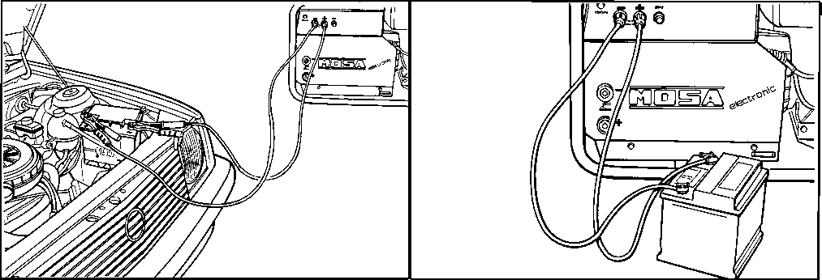

Connect the machine with the battery taps (12V or 24V) of the machine engine of which must be started, respecting the polarities (+) et (-).

Fally insert the cable plugs into the corresponding sockets (34-34A) turning them clockwise to lock them in position.

Accelerate the engine so that the voltmeter (N) shows the value reported on table (*).

PUSH AND TWIST

11/01/01 M35GB

TS  Model | Battery voltage | Voltmeter indication(*) | Battery voltage | Voltmeter indication(*)
180 | 12V | 120V | 24V | 235V
180 P | 12V | 190V
181 | 12V | 120V | 24V | 235V
181 P | 12V | 190V
200 | 12V | 120V | 24V | 235V
200 P | 12V | 190V
222 | 12V | 235V | 24V | 235V

Once the engine is started, bring back the engine IMMEDIATELY to MINIMUM speed.

Disconnect the connection cables of the battery.

If the engine fails to start, do not insist for at least 15 seconds.

Space the further operations waiting for at least 4 minutes.
CAUTION

© MOSA | REV.1-09/06 | USE AS A BATTERY CHARGE | GE_, TS_ | M 36

BATTERY WITHOUT MAINTENANCE
Connect the cable + (positive) to the pole +
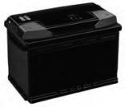
(positive) of the battery (after having taken away the protection), by properly tightening the clamp.
Check the state of the battery from the colour of the warning light which is in the upper part.

- Green colour: battery OK
- Black colour: battery to be recharged
- White colour: battery to be replaced

DO NOT OPEN THE BATTERY.

ENGINES WITH ACCELERATOR LEVER

Connect with the right cable the battery clips and the machine taps respecting the polarities (+) and (-).

Operate the accelerator lever bringing the engine to MAXIMUM speed.

Start the engine.

ENGINE WITHOUT ACCELERATOR LEVER

Connect with the right cable the battery clips and the machine taps respecting the polarities (+) and (-).

It is possible to draw at the same time direct current as battery charger and alternating current (auxiliary).
CAUTION

MACHINE WITH THERMIC PROTECTION

If the thermic protection is released, disconnect the cable from the machine.

Reset the thermic protection pressing the central pole.

PRESS TO RESET

Then connect again the cable with the machine.

In case the thermic protection should still intervene, check the battery.

If the trouble persists, please turn to your Service Station.

14/06/99 M36-GB

© MOSA | 1.0-06/99 | USE AS A GENERATOR | GE_, MS_, TS_ | M 37

☞ It is strictly forbidden to connect the group to the public mains a/o to another source of electric power.

Sockets are not self-locked: tension is avaible immediately after starting also with no plug.
WARNING
☞ N.B.: if the warning light does not flash, check the accelerator which must bebat its
maximum, or the fuse of the relevant socket. (single-phase) or the thermoprotection.

Using several sockets at tha same time, the maximum power possible is that indicated on the data plate.

To draw power simultaneously in the TS welder version see page M52.

☞ At the beginning of every work, check the electric parameters and/or the controls placed on the front.
The replacement of the fuse must absolutely be done with the engine off (remove the mechanical protection, then shift down the small lever of the fuse holder placed on the front panel).
CAUTION
The areas, access of which is forbidden to unqualified personel, are:
- the control switchboard (front), the exhaust of the endothermic engine.
WARNING

Make sure the unit is properly grounded (12) (where it is assembled).
- See page M20, 21, 22, 25, 26, 27 -.

Move the accelerator lever (16) and reach the engine maximum speed, except for the engines with constant rpm; the voltmeter (N) (where it is assembled) shows the single-phase voltage whether three or single-phase current has to be drawn.

Nominal voltage | Indicative no-load voltage
 | asynchronous | synchronous (*)
110V | ±10% | ±5%
230V | ±10% | ±5%
230V | ±10% | ±5%
400V | ±10% | ±5%
*N.B.: with electronic tens. regul. RVT ±1%

Connect up the machine, using proper plugs and cables in good condition to the AC socket (15) to draw single or three-phase power, or, by cables with adeguate section, to the terminal board, placed inside the derivation box (Q3).

The max. continuous power of the generating set or theload current must not be exceeded.

MACHINE WITH THERMOPROTECTION

If you overload the genset the thermoprotection will automatically switch off.
lf the thermoprotection is released, disconnect all the connected loads.

CLOSED OPEN

Reset the thermoprotection pressing the central pole.
When reset, connect the loads again.
In case the protection should act furtherly, check: the connections, the wires or others, and if necessary call the Assistance Service.
AvoId to hold the central pole of the

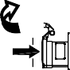PRESS TO
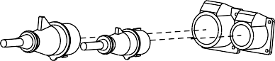
RESET
thermoprotection pressed for a long time.

The warning light (L), located near the current socket, lights up when the unit can supply alternated current, on condition that the engine is at the maximum rpm.
Otherwise, in case of trouble, it will not click,
damaging the generating set.
16/06/99 M37-GB

© MOSA | 1.0-06/99 | USE AS A GENERATOR | GE_, MS_, TS_ | M 37.1

TS ... PL VERSION
Start the machine and wait for the end of the preheating time imposed by the EP1, EP2, EP5 engine protection device. - See pages M39... - Press the „generation possibility“ push button (B5) placed on the font side of machine.
The voltmeter will show the auxiliary voltage which, for machines at 1500/1800 RPM, must. be approx.
≈230V ± 10% and for machines at 3000/3600 RPM (engine idling) must. be approx. ≈180V ± 10%.

Push upwards the lever of magnetothermic switch reffering to the socket from which load is to be drawn.

MACHINE WITHOUT PROTECTIVE DEVICE
In case machine is not equipped wìth protective device of indirect contacts, by means of automatic breaking of supply, it is necessary to put between the load and the generatíon a differential swítch or a similar equipment capable, in any case, to observe the regulations in force CEI 64/8 (and/or successi- ve) Part 4 Par. 4.13.1 and harmonzed by directive Nr. 72/23/EEC.

UNIT FITTED WITH GROUND FAULT INTERRUPTER SWITCH (GFI)

Turn on the GFI safety-switch
(D) by pushing it upwards.

The GFI is a safety device which protects the circuit in the event of a malfunction. In this case the switch disconnects the three and single-phase circuit when in any part of the electric connections a current leakage of more than 30 mA occurs.

UNIT FITTED WITH THERMAL MAGNETIC BREAKER
UNIT FITTED WITH GFI SWITCH THERMAL MAGNETIC BREAKER

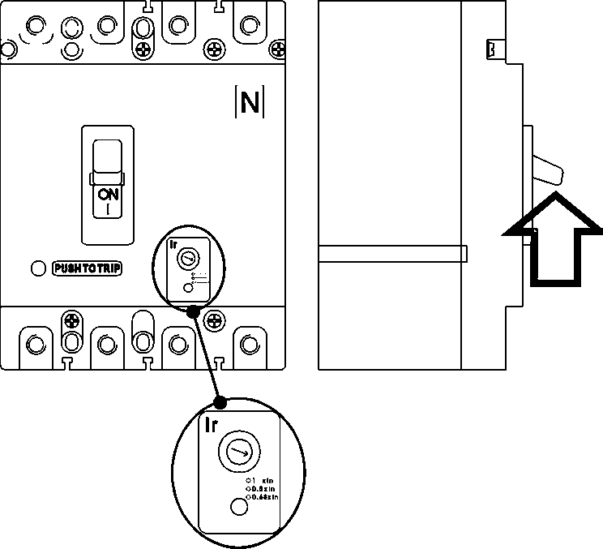
This switch includes the characteristics of both types of breakers (N2).

UNIT WITH VOLTMETRIC COMMUTATOR (ONLY FOR GENERATING SET)
☞ WARNING: the possible single-phase loads must
be correctly divided in the three phases, in order to avoid any possible voltage fall on one phase that results excessively loaded.
Check the voltages on the various phases with the switch located on the front (H2) and check, reading on the voltmeter (N) about the same voltage value
☞ N.B.: in case of overload, it is possible that the engine lowers its speed and the voltage
is reduced remarkably. In this case, it is necessary to reduce immediately the load.

Turn on the thermal magnetic breaker (Z2) by pushing it to the ON position.

The thermal-magnetic breaker
is a safety device which
For machines at 3000/3600 RPM the EP1 safety device will automatically provide to accelerate engine when load is drawn.
- See page M39.1 -
CAUTION
protects the circuìt in the event of a malfunction. In this case the switch disconnects the three and single-phase circuit when in any part of the electric connections a short circuit or a current absorption occurs above the data specified on the label of the unit.
In the model with setting DO NOT INTERVENE on the setting itself. To modify it, please contact our Technical Assistance Service.
16/06/99 M37-GB

© MOSA | 1.1-06/05 | ACCESSORY USE | REMOTE CONTROL TC2 / TC2/50 | M 38

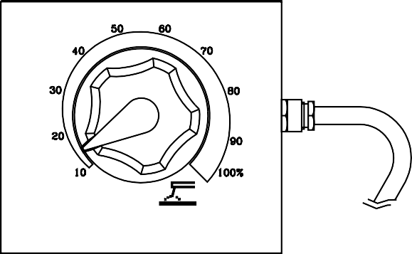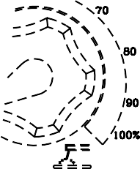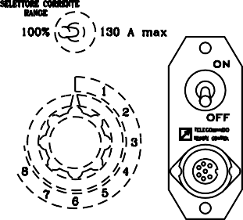
ON
OFF

PUSH AND SCREW TIGHT

The remote control device for regulating the welding current is connected to the front panel by means of a multipole connector.

To regulate the current from the TC2 / TC2/50, move the switch (7), located above the multipole connector (8), to "ON" position.

Position welding current adjusting (T) knob at the necessary current value for the diameter and type of electrode.
09/11/99 M38GB
- See page M51 -

© MOSA | 1.0-04/04 | TROUBLE SHOOTING | TS | M 40.1

PROBLEM
No welding current but auxiliary output is OK

Weld poorly

Intermittently welds poorly

No welding output and no auxiliary power output
2) Problem with welding current control
PCB
2) Replace the welding current control PCB
POSSIBLE CAUSE
- Defective diode bridge

- Problem with welding current control (PCB)

- Defective diode bridge

- Problem with welding current control (PCB)

1) Bad connections to welding current PCB

- Short circuit in wiring

- Defective condenser

- Defective stator

- Short circuited diode bridge
WHAT TO DO
- Check the diodes of the bridge
- Is the remote control switch in the internal position?
- Check the diodes and SCR’s of the bridge.
- Check the transformer which supplies power to the welding control PCB. If it is OK replace the PCB

- Check the open circuit welding voltage.
If it is OK the diode bridge is OK. If it is 1/3 or 2/3 of the nominal value check the diodes or the SCR’s.
- If the diode bridge is OK replace the PCB.

1) Check that the pins of the green connectors are clean and making good contact.
Check that shunt connections are tight.

- Check the wiring inside the welder for a short circuit between cables or to ground.

- If the wiring is OK, short circuit the condenser to be sure that it is discharged, disconnect all wires from condenser and, using an ohmmeter, check that the condenser is not short circuited.
- If the condenser box is OK, disconnect all leads from the stator except for those going to the condenser box and check the output from the alternator.
If there is no output from the welding winding and the auxiliary winding, replace the stator.
- If there is output from all windings reconnect the diode bridge and check if there is welding current. If not the diode bridge is defective. If there is welding current connect the auxiliary power leads one at a time until there is no output; at this point, the short circuit is in that line.

only for models with electronic control of welding current.
06/04/04 M40-1-I

